**Experiment - 1.2**

**Student Name: Vivek UID:**

**Section/Group: Branch: BE-CSE**

**Subject Code: 21CSH - 214 Subject Name: DBMS**

**Date of Performance: 02/09/2022 Semester: 3rd**

**AIM:**

To explore “SELECT” clause using where, order by, between, like, group by, having etc.

**DBMS script and output:**

**Creating Tables and inserting values:**

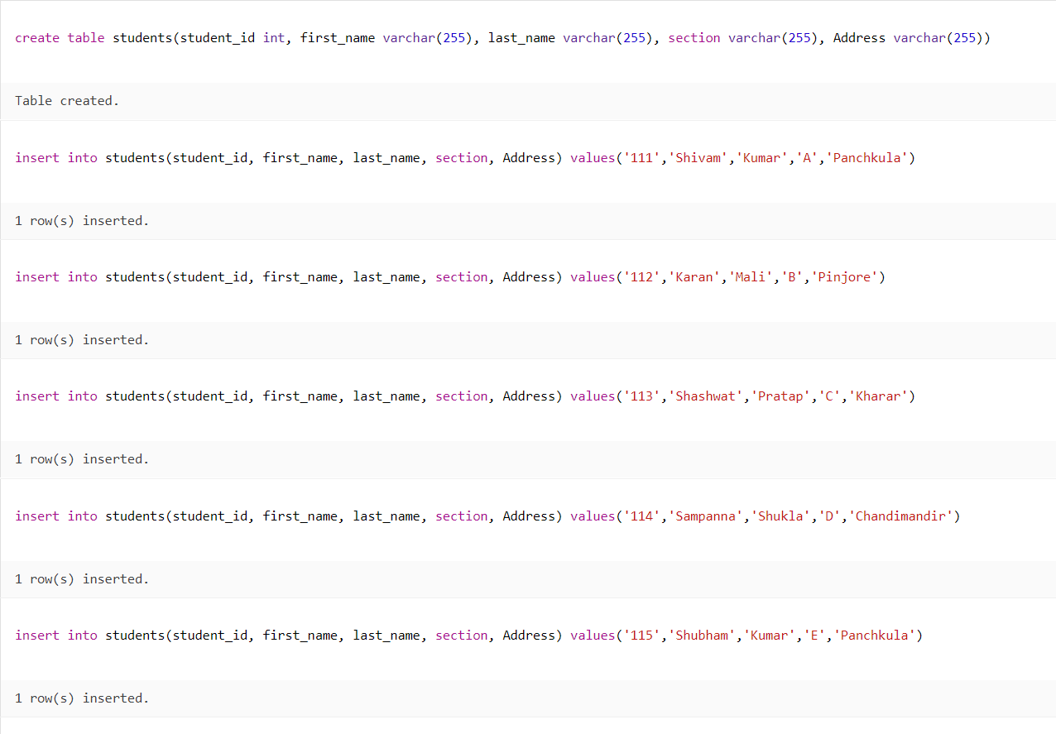

**WHERE Command:**

Syntax: select * from *table_name* where *Condition*;

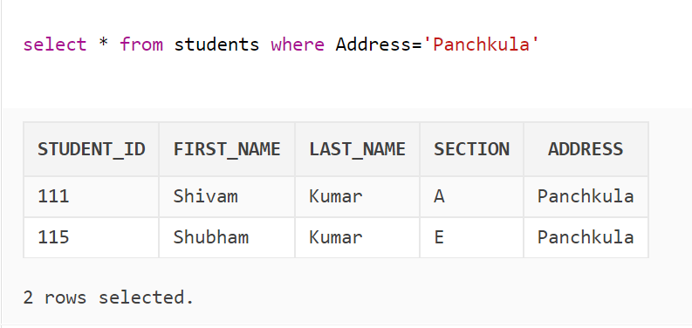

**LIKE Command:**

Syntax: select * from *table_name* where *Condition* like *pattern*;

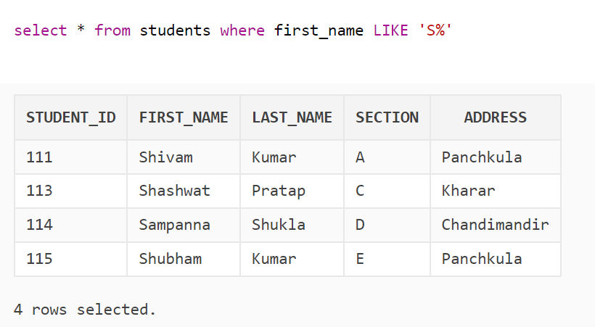

**IN Command:**

Syntax: select * from *table_name* where *Condition* in *(select statement)*;

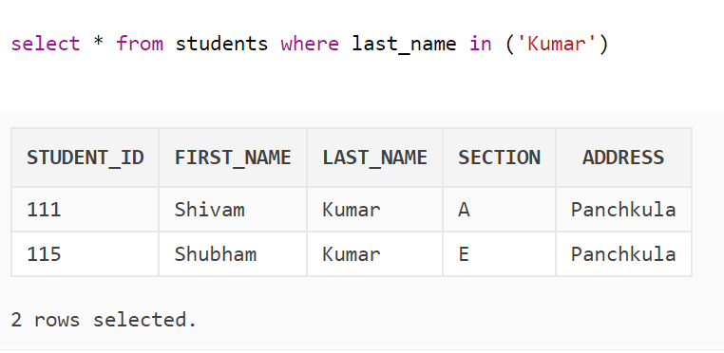

**BETWEEN Command:**

Syntax: select * from *table_name* where *Condition* between *value1* and *value2*;

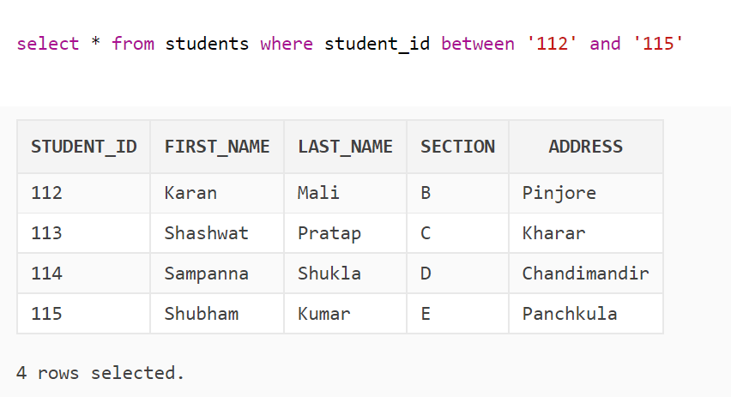

**ORDER BY Command:**

Syntax: select * from *table_name* where *Condition* order by *column_name*;

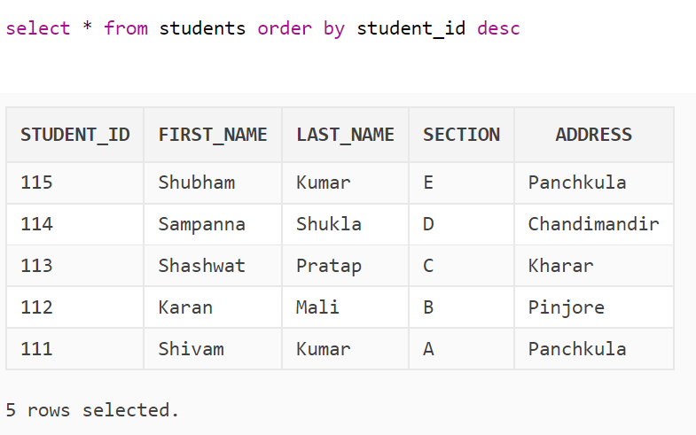

**AND Command:**

Syntax: select * from *table_name* where *Condition1*  and *condition2*;

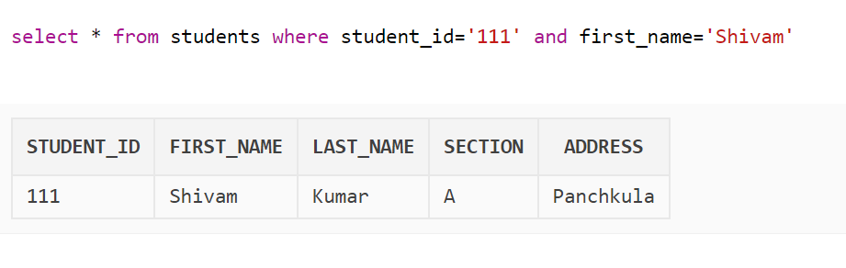

**OR Command:**

Syntax: select * from *table_name* where *Condition1* or *condition2*;

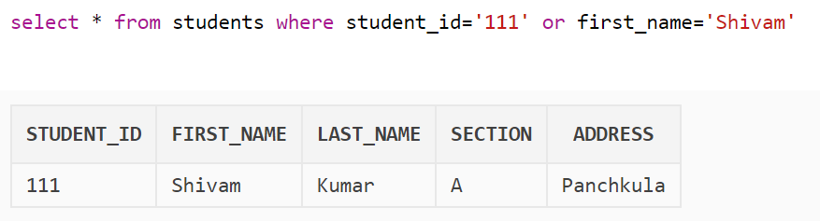

**GROUP BY Command:**

Syntax: select * from *table_name* where *Condition* group by *column_name*;

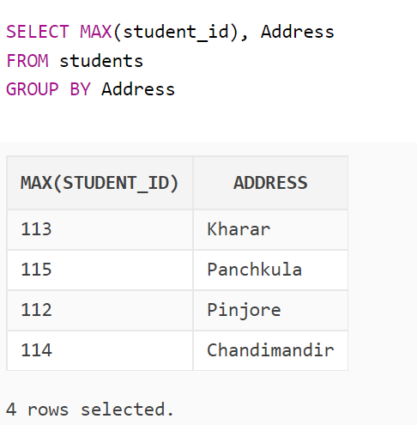

**Learning Outcomes:**

1. We have learnt about using different clause to use with SELECT command.
2. We have learnt about applying aggregate functions in my sql.
3. We have learnt about applying conditions on tables.

**Evaluation Grid:**

|  |  |  |  |
| --- | --- | --- | --- |
| Sr. No. | Parameters | Maximum Marks | Marks Obtained |
| 1. | Worksheet completion including writing learning objectives/Outcomes. (To be submitted at the end of the day). | 8 |  |
| 2. | Viva Voce | 10 |  |
| 3. | Student Engagement in Simulation/Demonstration/Performance and Controls | 12 |  |
|  | Signature of Faculty (with Date): | Total Marks Obtained out of 30: |  |